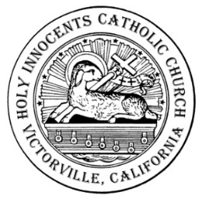
Holy Innocents Catholic Church
NAME CHANGE AND/OR CHANGE OF ADDRESS
Please print clearly.

Today’s date: ______________________
Name
(as you are presently registered) :__________________________________________________________________________________________________________
Envelope No.

New Name
(as you wish to be registered) :____________________________________________________________________________________________________________

Old Address:
__________________________________________________________
Street Number Street Name Apt. #

__________________________________________________________
City State Zip

______________________________
Telephone Number

New Address:
__________________________________________________________
Street Number Street Name Apt. #

__________________________________________________________
City State Zip

______________________________
Telephone Number

Do you wish to remain in Holy Innocents Parish as an active member Yes
(“active” means, contributing to the life of the parish financially and/or No
by participating in on or more of the parish’s ministries)? (Please mark one)

Comments:
_______________________________________________________________________________________
________________________________________________________________________________________
________________________________________________________________________________________

